The registry is responsible for the administration of the Commission.

Operations
During the 2019-20 fiscal year the Commission received 7,348 notices of which 4,941 were within the Commission’s jurisdiction. The occurrence of COVID-19 and required social distancing and lockdowns affected the operations of many government departments. One of the results of the pandemic for the Commission was a decrease in notices received from the 2018-19 year. The majority of notices received this financial year were for school attendance, followed by Magistrate Court, child safety and welfare and then domestic violence offences. Information regarding our performance during the year is located in the Review of non-financial performance commencing on page 19 and the Review of financial performance commencing on page 30.

At a glance – the 2019-20 year
7,348  Agency notices assessed | 4,941  Agency notices deemed within FRC’s jurisdiction | 1,217  Community members deemed the subject of agency notices
2,228  Conferences held | 811  Community members prioritised for conference | 0  Appeals of FRC decisions

An operational review to provide a priority focus
On 17 December 2019 an internal FRC Operational Review Workshop was held. It included year-to-date reflections on key processes and the analysis of data across all communities incorporating the timeliness of dealing with matters, holding conferences and making decisions. Following this, FRC Commissioner Tammy Williams commenced the new year by leading a Strategic Planning Workshop on 21 January 2020. The event was attended by registry staff and Local Commissioners Vera Koomeeta from Aurukun, Elaine Liddy from Coen, Doreen Hart from Hope Vale and Loretta Spratt from Mossman Gorge. Unfortunately, Chris Logan the Local Commissioner representative from Doomadgee advised of his inability to attend the workshop and alternative arrangements for a replacement were unable to be made at short notice.
Specific dashboard data for each community was presented to the Local Commissioners. Honest conversations were held to identify and agree on what successes had been achieved, and conversely what changes were needed to improve efficiencies, how to implement solutions, setting and tracking performance against targets and being accountable for results achieved. Training was conducted covering new practice directions and conferencing techniques to improve on early intervention, and making quality decisions to support changes in behaviour. Each Local Registry Coordinator then met with their Local Commissioner representative to establish community action plans for the 2020 year.

Re-alignment of organisation structure to improve efficiencies and outcomes
Business and operational strategies this year have focussed on maximising results for FRC clients by internally strengthening the FRC model to achieve accountability and continued relevance in a changing policy environment. The administrative functions of the registry had traditionally been split into two teams: corporate and operations. As part of our re-alignment the operations team has been split into two further distinct workgroups to provide for an integrated and coordinated client-centered case management structure:
- Coordination team – facilitates the holding of quality conferencing for clients where early intervention decisions are made by Commissioners to support positive behaviour change through a network of referral pathways to support services. The Coordination team is comprised of Local Registry Coordinators responsible for overseeing the Commission’s operations in each community and maintaining local and regional level partnerships with service providers. The Coordination team also briefs the FRC Commissioner and Registrar on systemic socio-economic issues impacting on the wellbeing of clients and their families and the restoration of socially responsible standards of behaviour. Where necessary these de-identified matters are reported in the Commission’s quarterly reports, or provided to the FR Board in out of session papers and correspondence for its consideration and appropriate action. Instances where issues were elevated to FR Board members include those matters set out in the performance highlights commencing on page 21. During the 2019-20 period the Coordination team facilitated 2,228 conferences across the five welfare reform communities.
- Case Management and Monitoring team – manages the holistic case monitoring of client progress towards achieving case plan goals and monitors income management orders for the duration of their Family Responsibilities Agreement (FRA) or decision by order following conference. The team makes ongoing assessments in consultation with Local Registry Coordinators and Commissioners as to whether further interventions are required. The Case Management and Monitoring team is also responsible for the initial processing of information received from notifying agencies during the intake phase of the Commission’s administrative processes. A determination is made whether the person/s named in the notice and their alleged conduct falls within the Commission’s jurisdiction. During the 2019-20 reporting period the Case Management and Monitoring team assessed 7,348 agency notices and deemed 67.2 percent (4,941) were within jurisdiction. A further intake assessment is made by the team under the direction of the FRC Commissioner for the prioritisation of clients where circumstances requires a mandated intervention (the listing for conference) by the Commission. Throughout the year 811 community members were prioritised for conference.

Administrative workforce
The FRC’s administrative workforce consists of:
- the FRC Commissioner (appointed by the Governor in Council for a specified term) who as the Chief Executive Officer (CEO) is responsible for ensuring the efficient discharge of the Commission’s business, appropriate training for registry staff and Local Commissioners, the preparation of corporate documents and achieving the objects of the FRC Act as specified in section 22 of the FRC Act
- the Registrar who is responsible for managing the registry and the administrative affairs of the Commission and whose functions, powers and delegation are specified in sections 35 to 37 of the FRC Act
- the Executive Officer (Finance) who is responsible for providing financial, and strategic/corporate advice and support to the Commission’s operations across Cairns and the communities and
- 15 positions across the three teams of Case Management and Monitoring, Coordination and Corporate, including four Local Registry Coordinators appointed under section 38 of the FRC Act to support the efficient and effective operation of the Commission in each of the welfare reform communities.
Further details in regard to the Commission’s workforce profile can be located in the Governance section of this report. Biographies of Commissioners and the Registrar can be found in the appendices (Appendix B).
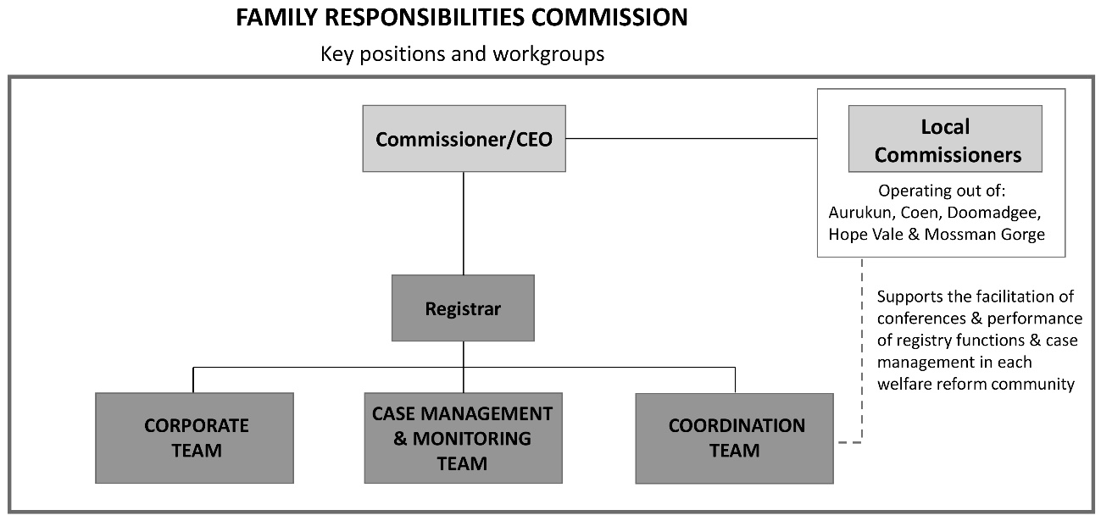

Client-focused data reporting
This year the FRC committed to report our activity in a manner to reflect a more client-focused data reporting framework as opposed to the historical process-orientated data we have reported since 2008. This change forms part of a broader internal review of data reporting which commenced in January 2020 aimed at more accurately documenting the Commission’s work and the benefits afforded to FRC clients. Feedback from our stakeholders indicates the level of client intervention provided by the FRC is of primary interest to readers of our quarterly and annual reports. Continuing amendments to our data reporting framework are planned to further define the level of client engagement and outcomes.

FRC decisions have an increased focus on capacity-building
Decisions can be made by agreement or order of the Commission. Community members can also voluntarily request referrals or income management. A continuum of possible decisions made at conference follows.
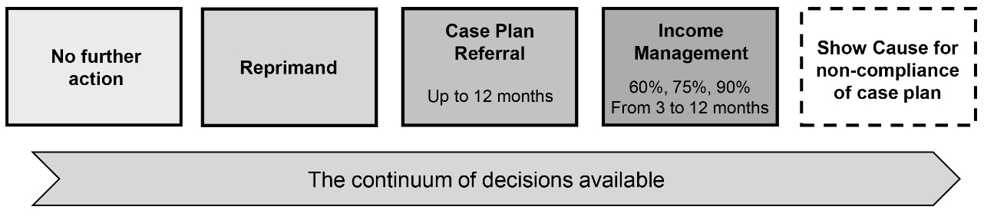

Section 5 of the FRC Act is clear in stipulating that matters should be dealt with in a manner that facilitates early intervention, delivers timely decisions, supports the change of behaviour sought, supports the exercise of local authority and makes use of community support services. The primary goal of the Commissioners is to enter into an agreement with the community member in the first instance. Clients may seek to amend or end a decision by demonstrating their circumstances have changed and children/vulnerable persons would not be detrimentally impacted by the alteration to the decision.
Activity for this reporting period has resulted in a significant increase in clients case-managed, up from 73 clients case-managed at the end of 2018-19 to 286 clients at the end of 2019-20. This growth resulted from an increase in agreements and orders made to attend community support services as shown in the following table, noting a client can have one or more agreements or orders. Further information in regard to conference activity and outcomes during the reporting period can be found in the Review of non-financial performance section commencing on page 19.

Conference outcomes for the financial year | 2018-19 | 2019-20
Agreements to attend community support services | 8 | 23
Orders made to attend community support services | 70 | 302

Referral pathways for clients and case management have grown significantly
Commissioners are guided by the FRC Act, sections 4 and 5, to encourage community members to engage in socially responsible ways, and in doing so, make appropriate use of community support services. The Commissioners use the referral pathways available in each community to strengthen the client’s resilience to face the challenges they experience, and to ensure the wellbeing and safety of children and vulnerable people through broad-based counselling and education.
During the conferencing process Commissioners may decide to refer the client to support services such as:
- Wellbeing Centres (WBCs) to address alcohol and/or drug misuse, gambling, domestic violence or social health related issues
- Parenting programs to assist in implementing good parenting practices
- MPower, a money management program, to assist with budgeting and meeting priority financial needs
- School Attendance Officers to assist parents to ensure children attend school or
- other appropriate support services.

As demonstrated in the table below the Commissioners have increased the referrals (nearly five-fold) from the previous financial year.

Number of referrals | 2018-19 | 2019-20
Referrals to service providers | 81 | 402

The increase of referrals in 2019-20 can be attributed to:
- the operational certainty provided to the Commission through a further funding commitment to June 2021 from the Australian and Queensland Governments which has encouraged stakeholders (including service providers) to invest in their engagement and referral activities with the Commission
- the availability of relevant service providers in each community and their renewed willingness to receive FRC client referrals and
- the increased confidence and growing capability of Local Commissioners to use a suite of techniques when conferencing clients with complex behaviours.
Where a client has multiple or complex issues to address, Commissioners may refer the client to more than one support service. Referrals to support services may be made on the basis of an FRA, where a client agrees to attend a support service and the client and Commissioners agree on the action to be taken together. Alternatively, Commissioners may make a decision to direct a client to attend a support service or services. Progress reports are received from service providers and clients are assessed to determine if they are fulfilling their obligations under the agreement or order. Together with local knowledge, additional information may be sought from agencies and service providers where appropriate to provide the best support possible for the client. The Commission is aided in this capacity by Part 8 of the FRC Act which outlines sophisticated provisions about information exchange between the FRC and relevant entities. Service providers and other persons who can make a useful contribution to the conferencing process are encouraged to attend conference proceedings and discuss the decision-making processes with the Commissioners.

Income management continues to be ‘an order of last resort’
At conference, a decision may be made to issue a client with a CIM order. Due consideration is given firstly to the individual circumstances of the client and whether alternative action is more appropriate. CIM orders are considered as a last resort, with Commissioners endeavouring to enter into an FRA with the client agreeing to income management in the first instance.
The Commissioners utilise CIM as a tool to support people and children at risk, promote socially responsible choices, and as an incentive to meet individual and community obligations by drawing together a network of support services to focus on the individual’s skills gaps (social and economic). CIMs are issued for a defined period (no longer than 12 months) with the Commissioners determining whether 60, 75 or 90 percent of fortnightly welfare payments are managed. Clients may apply to the Commission to have their CIM amended or ended. Commissioners consider each application to ascertain whether the client has made sufficient progress to justify an amend or end decision.
A community member may also enter into a Voluntary Income Management (VIM) agreement to assist them to manage their budget and meet the costs of everyday essentials. The Commissioners consider the number of VIM agreements entered into as indicative of a willingness of community members to take responsibility, to look after family members, and as a general improvement in community social norms. VIM agreements are a useful tool to assist elderly community members (who have not otherwise been referred to the FRC) to ensure their welfare payments are expended on their own needs.
As demonstrated in the table following, the growing number of clients placed on a case plan without a CIM during this reporting period clearly demonstrates that income management is delivered with a highly targeted and flexible approach nuanced to the client’s circumstances.

Clients placed on case plans and CIMs for the financial year | 2018-19 | 2019-20
Number of clients placed on a case plan and CIM | 36 | 112
Number of clients placed on a case plan without a CIM | 37 | 174
Number of clients placed on a CIM without a case plan | 140 | 53

Applications to amend or end agreements or orders
Applications to amend or end an agreement or order are considered an important means of ensuring that FRC decisions remain applicable to the changing needs and circumstances of clients. This mechanism affords clients an opportunity to apply to the Commission to amend or end their agreement or original order by providing their reasons for making the application. Commissioners view the hearing of the applications as an opportunity to engage with clients. Each application is considered by the Commissioners on its own merit whilst observing the principles of natural justice. A decision on the application is made pursuant to section 99 or section 109 of the FRC Act and may include either agreeing or refusing to amend or end an agreement or order, or if the Commissioners deem the application frivolous or vexatious, dismissing the application. The opportunity afforded in hearing these applications is utilised by the Commissioners to encourage clients to continue to address any remaining challenges and to exercise personal responsibility in their lives.
Amend or end applications received for the financial year | 2018-19 | 2019-20
Applications to amend or end received | 56 | 62

A case plan can have multiple referrals e.g. a client may be referred to both the Wellbeing Centre and MPower under the same case plan.
During conference the 23 agreements and 302 orders to attend community support services and the 219 CIM orders relate to 339 unique clients.

